Janis Gonzalez

WEB 335 Introduction to NoSQL

Assignment 5.2 Projections

April 16,2023

Bellevue University

1. query to add a new user to the user’s collection

db.users.insertOne({ firstName: 'Giuseppe', lastName: 'Verdi', employeeId: '444', email: '[verdi@me.com](mailto:verdi@me.com)', dateCreated: new Date });  
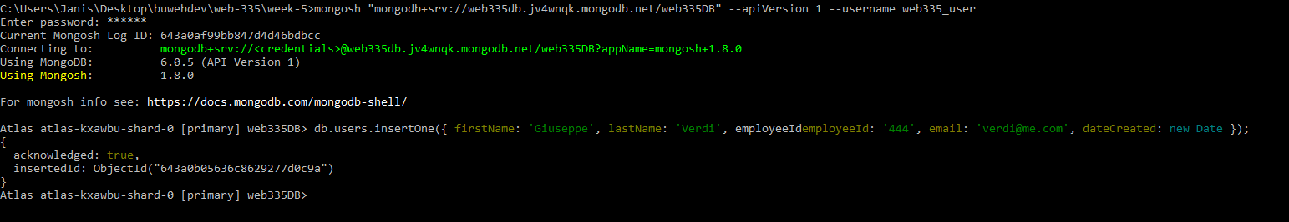

2. query to update Mozart’s email address to [mozart@me.com](mailto:mozart@me.com)

db.users.update({ email: "[wmozart@me.com](mailto:wmozart@me.com)" }, { $set: { email: "[mozart@me.com](mailto:mozart@me.com)" } })

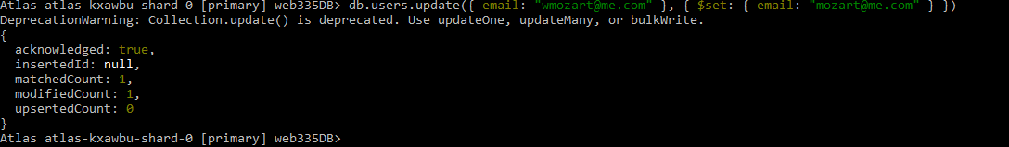

3. query to prove the email address was updated

db.users.find({ email: '[mozart@me.com](mailto:mozart@me.com)' })

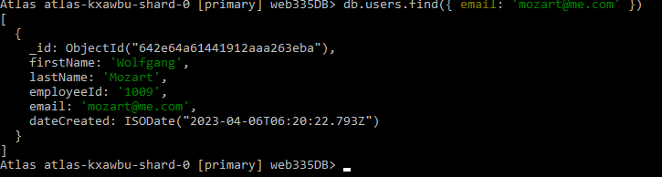  
  
4. query to list all documents in the user’s collection and with projections to only display the firstName, lastName, and email

db.users.find({}, { firstName: 1, lastName: 1, email: 1 })

